DRIVER ALERT SYSTEM ABSTRACT (MT2192)
Here we are in the 21st century, 2001 has already gone by, the space station wheel and regular flights to the moon via the Clipper ship predicted in Arthur C. Clark's sci-fi movie, "2001 a Space Odyssey" is still not a reality. Great strides are being made with the International Space Station. But for us earthbound inhabitants having to drive to work each day or truck drivers going on long hauls across our long transcontinental highway system life can be pretty lonesome. Lone truck drivers and drivers with a long commutes who have no one to talk to or alert them if they happen to get sleepy can get in serious trouble on our busy highways. This is especially true during the twilight and sundown hours when lighting becomes subdued. In an emergency situation reaction times can be in milliseconds to maneuver from a collision with another vehicle. As I commute to work early each morning I feel I can understand how an astronaut or cosmonaut must feel while traveling through the darkness of space to the International Space Station or even to the Moon.

While I am sure major auto makers and NASA are working on this problem, and maybe even the luxury cars already have such a system in place, I built this prototype version shown in Photo 1 in order to carry out experimentation during my long commute. I used the Microchip dsPIC 1.1 Development Board for the data collection, real-time graphics LCD display and algorithm processing and a my own designed Motor Controller Board, which uses a dsPIC30F4011 to drive the road grating noise generator motor attached to the driver’s seat. Evaluation Kit. In addition I used a Freescale Zigbee based wireless SARD X,Y and Z accelerometer board to measure the driver’s head orientation. The system consists of the vehicle operator wearing a baseball cap or headband with the X-Y and Z accelerometer mounted or clipped on while running the Freescale TRIAX application. The Driver Alert Module processes data and transmits it to the embedded dsPIC30F6014 Driver Alert Controller via the serial RS-232 interface during drives. The block diagram for the operational system is shown in Figure 1.

Figure 1 – Block Diagram for the operational system.
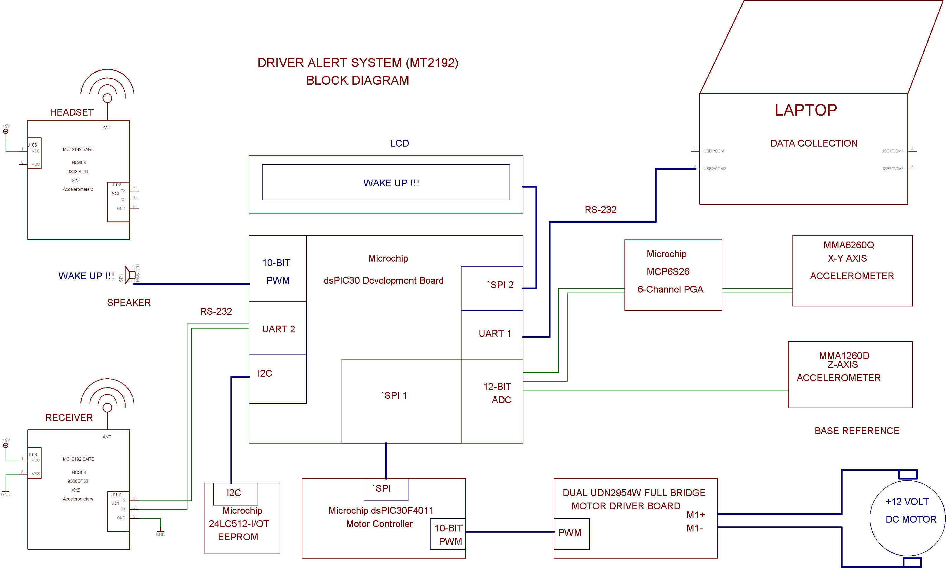

The Driver Alert System also provides high speed Microchip PIC18F4550 USB 2.0 based hardware interface to be used for data collection and simple algorithms to detect if the driver is awake or driving erratically and to alert the driver if he/she is falling asleep at the wheel. Sophisticated alertness algorithms could be developed using Neural Networks (NNs) and Fuzzy Logic algorithms to determine if the driver is alert, but these are beyond my capabilities and resources at this time. Instead, I intend to collect the data and perform some simple analysis using MATLAB to determine if the data collected can used to determine if the vehicle operator is driving normally or erratically by measuring the position (X,Y,Z) and the orientation (pitch, yaw and roll) of the operator's head with respect to the operator's normal field of view (FOV). In other words the driver should be roughly horizontally using maybe up to 120 degrees (panoramic) and not jerking his/her head or staring down at the floor or the looking up at the ceiling while driving. Time measurements are made of the driver’s HEADSET orientation to make sure that he/she is paying attention to the road.

This system could also benefit operators who may have unknown medical conditions such as a weak heart, encounter sudden (first time) fainting spells, or seizures, where their behavior suddenly changes. It can even warn those who are driving under the influence to pull over and call a taxi or their loved ones to get them safely home.

Photo 1 - The Driver Alert System hardware includes the Microchip dsPIC30 Development Board, a HEADSET and a BASE Reference Virtual SARD and the Freescale wireless SARDS used to obtain x-y and z acceleration data.
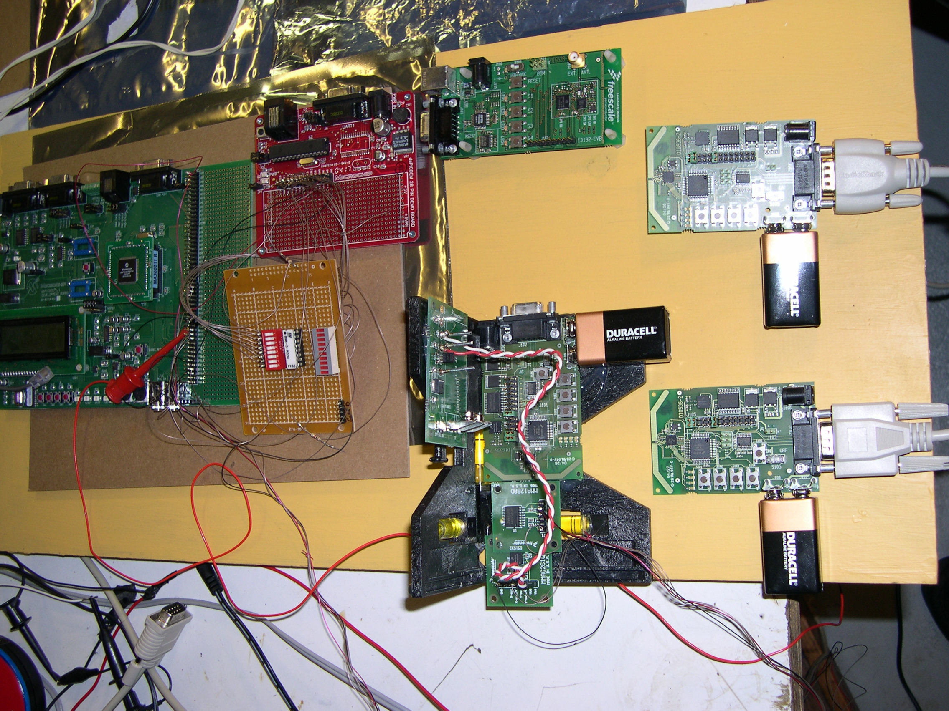

Correlation of the data during a normal (safe) commute and an abnormal (simulated by contrived means in a vehicle at rest) is accomplished with TRIAX data collected by the dsPIC30F6014 micro-controller and a PIC18F4550 USB 2.0 Controller. The final determination and selected alert processed with the laptop using Microsoft Visual C++ and GNAT Ada 95. In order to obtain the absolute orientation it may be necessary to include a second SARD board (BASE Reference) fixed on the vehicle's dashboard.

So as not to startle the vehicle operator and unintentionally cause an accident, the audible alerts will consist of gradually playing recordings made by the operator's loved ones urging them to pull over or to get a cup of coffee, or using a recording of their pet dog barking. The driver’s seat will start vibrating, simulating the grating sound on the sides of US Highways. The alerts will be issued whenever the Driver Alert Controller detects abnormal or erratic driving. These alerts are recorded and played back using the laptop’s speakers and maybe even the vehicle's speakers. Another alert can be provided by playing a track (*.WAV) from their favorite music (guaranteed to wake them up). In the event that the system detects an emergency situation, it could be connected to the vehicles emergency switch (panic button with a red triangle) so as to warn other drivers on the road.

Since I do not have the enormous resources that an auto manufacturer or NASA has, I cannot fully test the system or guarantee that it will work for everyone. It is only a prototype and should be treated as such and not used as a safety device since it has not had the rigorous development and testing required for an automotive application. Rather think of it as device that hopefully will be included in the array of vehicle safety devices such as the Air Bag now common in all new vehicles. The commercial version would consist of a high end Microchip dsPIC33 Digital Signal Processor (DSP) or PIC24 16-Bit micro-controller integrating all the functionality of the laptop, thus reducing the unit price needed for the highly competitive automotive industry.

MICROCHIP PARTS USED
- dsPIC30F6014 Telepod Controller (Microchip dsPIC 1.1 Development Board with graphics LCD Display )
- dsPIC30F6014 Wireless Joystick Controller Board (DIY wire-wrapped board)
(3) dsPI|C30F4011 Motor Controller Boards (PCB)
- PIC18F4550 USB 2.0 Controller (PICDEM Full Speed USB Demo Board, DM163025)
(1) PIC18F242 (Graphics LCD Controller on Microchip dsPIC 1.1 Development Board)
(1) 24LC512-I/OT 512 Kb Serial I2C EEPROM
(1) MCP6S26 6-Channel PGA

The detailed schematic of the Microchip Driver Alert consists of using the dsPIC30F601416C84 as the main controller and using two Freescale SARD(s) to collect the xyz data is shown in Figure 2.

The detailed schematic of the Microchip Driver Alert consists of using the dsPIC30F6014 as the main controller and using two Freescale SARD(s) to collect the xyz data is shown in Figure 2.
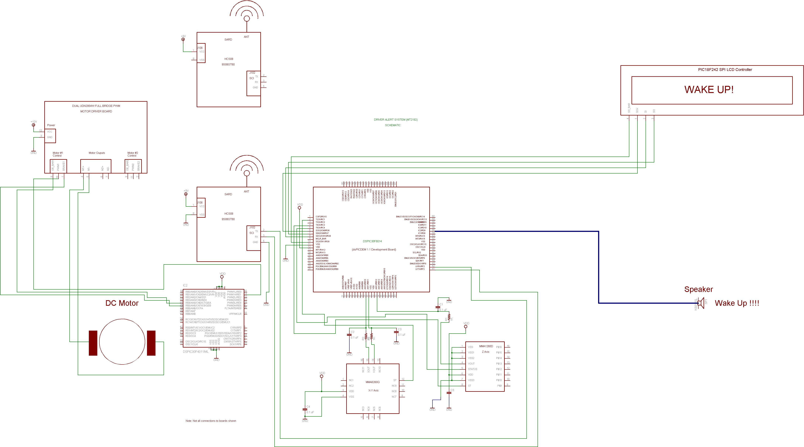

The complete article, photos and remaining figures 2-9 in the project directory show how the Driver Alert System works.

FIRMWARE
Listing 1 – is an example of how I collect XY and Z accelerometer data from the Freescale based Virtual SARD using the Microchip dsPIC30F6014 12-Bit ADC and the 16-Bit timers. The information gathered is used to determine if the operator is not paying attention to the road or is falling asleep.

Listing 1 - The basic Driver Alert Processing Algorithm currently flashed on the dsPIC30F6014 using Microchip C code to detect if the driver is falling asleep.

//********************************************************************************

// Driver Alert Algorithm 3 - Collect and process HEADSET and reference data using UART 0 and UART 1. The HEADSET SARD transmits the
// data to the receiving BASE SARD using the wireless Zigbee protocol. A Virtual Reference SARD uses the on-boad 12-Bit ADC to read
// the reference xyz accelerometer values that are then subtracted from the HEADSET xyz accelorometer values before they are thresholded.
// During data collection the data is reformatted and sent to the PC or laptop using UART 0. The format used is t x1 y1 z1 x2 y2 z2,
// where t is the current time stamp in milliseconds. The xyz accelerometer data may be filtered or averaged using three 16-element
// circular buffers by setting the FILTER define flag.
// Note: Be sure to use a Null Modem cable for the connection between the SARD and the dsPIC30F6014 .
//********************************************************************************

// Reset Counters Here
X_Axis_Time_Count = 0;
Y_Axis_Time_Count = 0;
Z_Axis_Time_Count = 0;

// Initialize SARD TRIAX Data Collection parameters here...
Lines = 0;
Number_Of_Samples = 10000;

printf("Start collecting SARD xyz data... \r\n");

// Start collecting TRIAX xyz data from SARD...

Start_Time_1 = Timer_Count;
Start_Time_2 = Timer_Count;

while (1)
{
//*****************************************************************************

//* H E A D S E T S A R D
//*****************************************************************************

// Get xyz angles from the HEADSET SARD here...

// Search for 'x'
while ((Xc = getch2()) != 'x');

// Read X value from serial port (COM3)
if (Xc == 'x')
{
Xb = getch2();
//printf("trace 1: Xc = !%c! Xb = %d \r\n", Xc, Xb);
}
else
{
printf("Error reading X value at line %d! \r\n", Lines);
goto NextValue;
}

// Read Y value from raw data file
Yc = getch2();
if (Yc == 'y')
{
Yb = getch2();
//printf("trace 2: Yc = !%c! Yb = %d \r\n", Yc, Yb);
}
else
{
printf("Error reading Y value at line %d! \r\n", Lines);
goto NextValue;
}

// Read Z value from raw data file
Zc = getch2();
if (Zc == 'z')
{
Zb = getch2();
//printf("trace 3: Zc = !%c! Zb = %d \r\n", Zc, Zb);
}
else
{
printf("Error reading Z value at line %d! \r\n", Lines);
goto NextValue;
}

//********************************************************************************

//* V I R T U A L R E F E R E N C E S A R D
//********************************************************************************

// Get xyz angles from the reference Virtual Reference SARD here...

while (!ADC_Data_Available);

result[X_INDEX] = ad2_value; // get AN2 (X-Axis) ADC data
result[Y_INDEX] = ad3_value; // get AN3 (Y-Axis) ADC data
result[Z_INDEX] = ad4_value; // get AN4 (Z-Axis) ADC data
ADC_Data_Available = FALSE;

// Subtract the Virtual Reference SARD xyz values read from the 12-Bit ADC from the HEADSET SARD xyz values and
// use the designated threshold values to Driver Compare against angles exceeded for too long (Driver Falling Asleep
// at the wheel or not paying attention to the road)

// (X,Y,Z) Angles read from the HEADSET SARD. Works!!!
X_Axis_Angle = (float)Xb * ConvertToDegrees8;
Y_Axis_Angle = (float)Yb * ConvertToDegrees8;
Z_Axis_Angle = (float)Zb * ConvertToDegrees8;

// Angles read from the (X,Y,Z) accelerometers. Works!!!
X_Axis_Ref_Angle = result[X_INDEX] * ConvertToDegrees - 90.0;
Y_Axis_Ref_Angle = result[Y_INDEX] * ConvertToDegrees - 90.0;
Z_Axis_Ref_Angle = result[Z_INDEX] * ConvertToDegrees - 90.0;

if (abs(X_Axis_Angle - X_Axis_Ref_Angle) > X_AXIS_THRESHOLD)
{
X_Axis_Time_Count++; // Increment # of 1 ms ticks that threshold was exceeded in X direction
if (X_Axis_Time_Count > X_AXIS_TIME_LIMIT)
{
X_Axis_Time_Count = 0;

// Sound the alarm to attempt to alert the drowsy driver by playing road noise and turning
// on the vibrator motor here...
Sound_Alarm();

}
}

if (abs(Y_Axis_Angle - Y_Axis_Ref_Angle) > Y_AXIS_THRESHOLD)
{
Y_Axis_Time_Count++; // Increment # of 1 ms ticks that threshold was exceeded in X direction
if (Y_Axis_Time_Count > Y_AXIS_TIME_LIMIT)
{
Y_Axis_Time_Count = 0;

// Sound the alarm to attempt to alert the drowsy driver by playing road noise and turning
// on the vibrator motor here...
Sound_Alarm();
}
}

if (abs(Z_Axis_Angle - Z_Axis_Ref_Angle) > Z_AXIS_THRESHOLD)
{
Z_Axis_Time_Count++; // Increment # of 1 ms ticks that threshold was exceeded in X direction
if (Z_Axis_Time_Count > Z_AXIS_TIME_LIMIT)
{
Z_Axis_Time_Count = 0;

// Sound the alarm to attempt to alert the drowsy driver by playing road noise and turning
// on the vibrator motor here...
Sound_Alarm();
}
}

// Display acceleration values to the LCD every 0.5 seconds (500 1 ms ticks)
//if ((Timer_Count % 1000) == 0)
//if ((Timer_Count % 500) == 0)
if ((Timer_Count - Start_Time_1) >= 500)
{
Start_Time_1 = Timer_Count; // Reset timer

// Clear LCD and home the cursor
Lcd_Clear();

// Angles read from the (X,Y,Z) accelerometers. Works!!!
X_Axis_Angle = result[X_INDEX] * ConvertToDegrees - 90.0;
Y_Axis_Angle = result[Y_INDEX] * ConvertToDegrees - 90.0;
Z_Axis_Angle = result[Z_INDEX] * ConvertToDegrees - 90.0;

Lcd_Set_Character_Position(1,0);
Lcd_Printf("X,Y,Z Tilt Angles");
Lcd_Set_Character_Position(1,1);
Lcd_Printf("X = %3.2f Degrees",X_Axis_Angle);
Lcd_Set_Character_Position(1,2);
Lcd_Printf("Y = %3.2f Degrees",Y_Axis_Angle);
Lcd_Set_Character_Position(1,3);
Lcd_Printf("Z = %3.2f Degrees",Z_Axis_Angle);

// Scale the accelerometer X,Y,Z reading from 12-Bits to 8-Bits to emulate the 8-Bit ADC on the TRIAX Boards
//map_window_to_viewport (result[X_INDEX], result[Y_INDEX], &X_Axis_Accel8, &Y_Axis_Accel8);
//map_window_to_viewport (result[Z_INDEX], result[Z_INDEX], &Z_Axis_Accel8, &Z_Axis_Accel8);

map_viewport_to_window (result[X_INDEX], result[Y_INDEX], &X_Axis_Accel8, &Y_Axis_Accel8);
map_viewport_to_window (result[Z_INDEX], result[Z_INDEX], &Z_Axis_Accel8, &Z_Axis_Accel8);

// Send data read from the BASE (Reference) Virtual TRIAX back to the laptop TRIAX application
//printf("X_Axis_Accel8=%d, Y_Axis_Accel8=%d, Z_Axis_Accel8=%d\r\n ", (byte)X_Axis_Accel8, (byte)Y_Axis_Accel8, (byte)Z_Axis_Accel8);

// Write the data to a Matlab "m" file

//printf("Xb=%d Yb=%d Zb=%d \r\n", Xb, Yb, Zb);
//fprintf(MatlabOutputFile, "x%dy%dz%d\r\n", Xb, Yb, Zb); // TRIAX Format
//fprintf(MatlabOutputFile, "%d %d %d \r\n", Lines, Xb, Yb, Zb, (byte)X_Axis_Accel8, (byte)Y_Axis_Accel8, (byte)Z_Axis_Accel8); // Matlab Format
// HEADSET SARD BASE reference Virtual SARD

// Send data with line count
//printf("%ld %d %d %d %d %d %d\r\n", Lines, Xb, Yb, Zb, (byte)X_Axis_Accel8, (byte)Y_Axis_Accel8, (byte)Z_Axis_Accel8); // Matlab Format

// Send data with time stamp in 1 ms tics
printf("%ld %d %d %d %d %d %d\r\n", Timer_Count, Xb, Yb, Zb, (byte)X_Axis_Accel8, (byte)Y_Axis_Accel8, (byte)Z_Axis_Accel8); // Matlab Format

}

NextValue:
Lines++; // Count number of lines read
if (Lines > Number_Of_Samples) goto ExitLoop;

}

ExitLoop:

printf("Stopped processing SARD xyz data. \r\n");

